INICIAL AGENDA
FIRST LEARNING ACTIVITY (LA) IN BERLIN
12TH to 16th of February, 2018

LOCATION: Berlin, Steinbeis University Berlin, Guertelstr. 29a/30, www.steinbeis-icrm.eu/
Steinbeis University Berlin
Institute Corporate Responsibility Management
Gürtelstr. 29 A/30
D-10247 Berlin
The Institute is located within the Steinbeis University building, 5th floor, at the end of the corridor, left side. After entering the building, if you take the second elevator at the end of the corridor, you will find the Institute right across you on the 5th floor.

ACCOMODATION:
Apartment Schultz (Prentzlauer Berg Area) booking.com
Apartments City Room (Prentzlauer Berg Area) booking.com
Pension Absolut Berlin (Prentzlauer Berg Area) booking.com
There is a suggestion to have a two shared apartments (male and female) with private bedrooms. Please say if you are interested to be accomodated in shared apartment.
Exampe:
4 Bedrooms + 2 bath, 110 sqm, balcony
Biggest home in Berlin's Heart

PUBLIC TRANSPORT IN BERLIN
5-Day Berlin Pass → EU 36.50
(incl. all public transportation, also from the airport - discounts in museums, restaurants - book online BEFORE you arrive in Berlin and print it out) BOOK HERE
6-Day Berlin Pass → EU 42
(incl. all public transportation, also from the airport - discounts in museums, restaurants - book online BEFORE you arrive in Berlin and print it out) BOOK HERE

___________________________________________________________________________

During five days of the Learning activity in Berlin, through lectures, sightseeing, webinar and interactive workshops, project partners will share the knowledge regarding the:

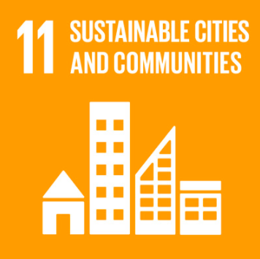
SUSTAINABLE DEVELOPMENT GOAL 11: Make cities and human settlements inclusive, safe, resilient and sustainable.
For the LA in Berlin all partners should have basic understanding and a few best practices (does not have to be from their countries) of SDG11.

UN agenda on Sustainable Development Goals (SDG) prioritizes concerns and action towards sustainability in an increasingly urbanized world that needs to put focus on social inclusion. Transforming diverse urban spaces to Sustainable Cities represent a mandatory field towards general sustainability goals. The City represents a medium where global sustainability goals find their local implementation and realization. Project partners intend to sum, evaluate and bridge different practice of sustainability achievements in national city cases, building a perspective towards unifying and connected global action.

For more information please go to:
- https://sustainabledevelopment.un.org/sdg11
- https://unhabitat.org/wp-content/uploads/2016/02/SDG-Goal%2011%20Monitoring%20Framework%2025-02-16.pdf

Working on the structure and content of the SDG handbook and Webinar.
- In order to achieve greater connection and education of target groups and different stakeholders, project consortium will, along the series of webinars, create 'Social SDGs Handbook' in .pdf format that will summarize the webinar and give a short introduction to every webinar in a written form.
- Considering the fact that there are nine SDGs, the Handbook will have nine chapters, with the introductory one. Since the issue of social SDGs is of a great scope and very complex the Handbook will function as an overview of each social SDG, as well as it will give the guidelines on using the webinars. Same as each webinar, the Handbook will present the accumulated knowledge of the exchange of good practice when it comes to each social SDGs.
- As the webinars, the Handbook will be written in English and free of use (pdf format).

Four topics will be discussed in their innovative potential, reflecting proclaimed SDG Sustainable City Goals 11:
- Safe, affordable housing with access to basic services (sustainable communal services, public transport, public spaces, road safety) (target 11.1)
Project partners will present examples of socially responsible urbanism oriented towards fulfilling social needs for affording housing to socially marginalized groups and quality public services to foster development and prevent urban decay. Further innovative potentials will be explored and defined in order to present possible pathways for further development. The goal is providing the right to the city for all citizens through social inclusion and socially responsible urbanism.

- Reduction of urban environmental impact (green spaces, air quality, waste management, renewable energy, smart buildings, sustainable urbanism) (target 11.6.)
Project partners will present successful sustainability practices and solutions in reduction of environmental impact of cities. Innovation is needed in this field from large scale projects to small city initiatives, so the exchange of experience plays an important role to providing knowledge needed for worldwide implementation. This topic is crucial for SDG goals so project partners intend to communicate on existing policy and actions and to propose a variety of solutions and innovative local practices applicable globally.

- Holistic Risk Disaster Management (adaption to climate change, resilience to natural and social disasters) (target 11.B)
Sustainable city is a resilient city managed carefully and prepared for environmental challenges. Project partners will elaborate on a diversity of environmental risks and possible intervention towards preventing, protecting and safeguarding cities in risk. Examples of good practice and innovative solutions will be evaluated and explored for further improvement and applicability.

- Technical and financial support to least developed countries (urbanisation in least developed countries, global support) (target 11.C)
The role of global community is to care for all social spaces and to improve those lacking in modernization. Channels of support should be provided for economic development, reduction of extreme poverty and regional integration, sustainable rural areas and empowerment of local citizens. Project partners will discuss potential roles of global community and effective policies and action towards deprivileged urban areas.

Additional to the group discussions and working on the topics, following guest speakers will share their knowledge and experiences, and give impulses for wider discussions and reflection:

Confirmed speakers:
- Prof. Dr. Wayne Visser
- Thomas Stellmach
- Yannis Salavopoulos
- Nadine Kuhla von Bergmann & Gian Marco Morigi
- Dr. Kosta Mathéy
- Abhay Adhikari, PhD
- Aristide Athanassiadis (Metabolism of Cities)
- Dr. Alexander Jachnow
- Azra Sulejmanpasic (Freewa)
- Jaka Ćosić, (GIS Cloud)

DAY 1 - 12TH of February, 2018

Project Topic Host: Global Impact Grid
Project Topic: SUSTAINABLE DEVELOPMENT GOAL (SDG)11
Time: 14:00 – 18:00
Location: Steinbeis University Berlin, Guertelstr. 29a/30, www.steinbeis-icrm.eu/

14:00 - 16:00
Presentations of the partners on the SDG11
Screening of segment from a film Closing the Loop

16:00 - 16:45
Presenter: Thomas Stellmach | Director TSPA, Planning Expert | UN-Habitat, Founding member | urban coop berlin eg

16:45 - 17:30
Presenter: Yannis Salavopoulos, MBA, BCI, Managing Director, CAPITALS Circle Group GmbH, Managing Director, Global Sustain GmbH
Prevent Risks - Lead Growth. Resilience & Sustainability Management as Drivers for Disaster Prevention and Recovery

17:30 - 18:00
Discussing the SDG Guide

DAY 2 - 13TH of February, 2018

Project Topic Host: Global Impact Grid
Project Topic: SDG 11
Time: 11:00 – 17:00
Location: Steinbeis University Berlin, Guertelstr. 29a/30, www.steinbeis-icrm.eu/

11:00 – 13:00
Urban Change Agents as Drivers of SDG 11 Goals (working title)
Workshop Concept & Moderation
Presenters: Nadine Kuhla von Bergmann, Gian Marco Morigi
Contribution by Creative Climate Cities
creativeclimatecities.org

13:00 - 13:15
Freewa Free water locator - example of best practice from Croatia
Presenter: Azra Sulejmanpasic (Freewa)

15:00 – 17:00
Urban Renewal and Revitalization (URR), Sustainability Lessons from European Experiences
Presenter: Kosta Mathéy, PhD

DAY 3 - 14TH of February, 2017

Project Topic Host: Global Impact Grid
Project Topic: SDG 11
Time: 09:00 – 15:00
Location: Study Tour in Berlin

9:00 - 10:00 Climate KIC Germany (waiting to be confirmed)
Address: EUREF-Campus, Torgauer Str. 12, 10829 Berlin
http://www.climate-kic.org/locations/berlin-germany/

Climate-KIC is the first place to go for game-changing climate innovation in Germany. The German office drives the development of scalable high impact climate change solutions with its programmes and its community of the most innovative companies, researchers, start-ups and students.

The visit to the Climate KIC office will focus on the activities within its incubator Green Garage, as well as its Urban Transitions activities for sustainable cities.

11:00 - 12:00 Infarm
Address: Glogauerstrasse 6, 10999 Berlin
http://www.infarm.com
https://www.youtube.com/watch?v=R-YTyt-3ZLc (Feature of Infarm Co-Founder)

Infarm is a vertical farming venture based in Berlin. It's innovative, full of passion, and at the forefront of urban agricultural sustainability initiatives.

100%  BERLIN  100%  NATURAL  100%  PESTICIDE-FREE | A HARVEST CREATED BY  FARMERS, SCIENTISTS, AND CHEFS.  VARIETIES FROM AROUND THE WORLD,  GROWN IN YOUR NEIGHBOURHOOD,  365 DAYS A YEAR.

LUNCH

14:00 - 15:00 Tour at Prinzessinnengärten
Address: Glogauerstrasse 6, 10999 Berlin
http://prinzessinnengarten.net/about/

Prinzessinnengärten is a new urban place of learning. It is where locals can come together to experiment and discover more about organic food production, biodiversity and climate protection. The space will help them adapt to climate change and learn about healthy eating, sustainable living and a future-oriented urban lifestyle.

Dinner in the restaurant and discussing the structure of the Webinar

DAY 4 - 15TH of February, 2018

Project Topic Host: Global Impact Grid
Project Topic: SDG 11
Time: 11:00 – 18:00
Location: Steinbeis University Berlin, Guertelstr. 29a/30, www.steinbeis-icrm.eu/

11:00 - 11:30
Smart cities of 21st century
Presenter: Jaka Ćosić, MSc in Spatial Planning and Regional Development (GIS Cloud)
https://www.giscloud.com/

16:00 - 17:30
WEBINAR: SUSTAINABLE DEVELOPMENT GOAL 11
Speakers:
- Abhay Adhikari, PhD
- Aristide Athanassiadis (Metabolism of Cities)
- Dr. A.R. Jachnow, Head of Urban Strategies and Planning (USP)

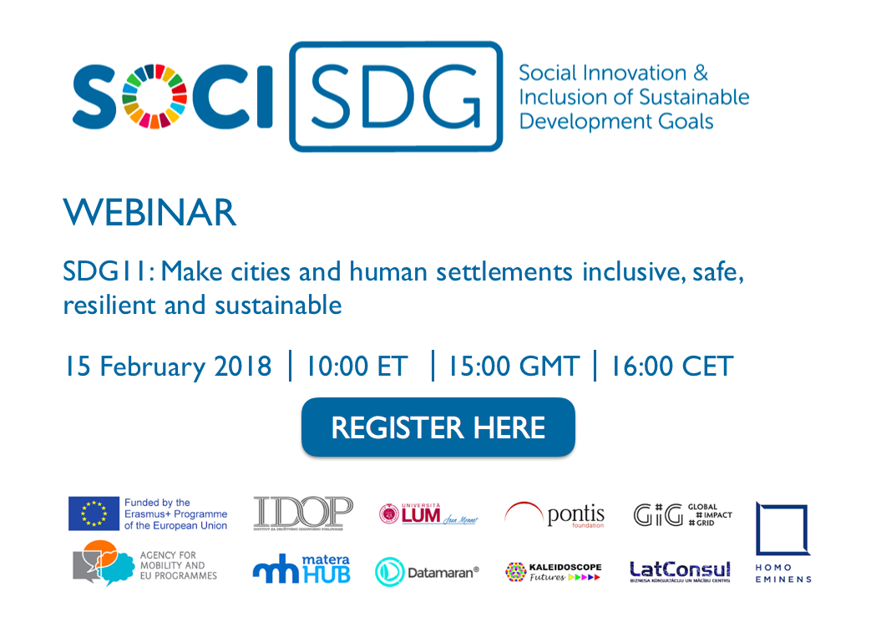

Link to register: https://goo.gl/forms/4d2zh9turUUzQnle2

DAY 5 - 16TH of February, 2018

Project Topic Host: Global Impact Grid
Project Topic: SDG 11
Speakers: TBC
Time: TBC (depending on the project partner’s departures)
Location: Steinbeis University Berlin, Guertelstr. 29a/30, www.steinbeis-icrm.eu/

